Dependency Injection (DI) in Spring

What is Dependency Injection?
Dependency Injection (DI) is a feature of Spring in which Spring provides the required object to a class instead of the class creating that object itself.
First, understand two basic terms:
- Dependency: An object that a class needs to perform its work.
- Injection: Providing that required object to the class.
In simple words, Dependency Injection means giving a class the object it needs from outside.

Real-Time Example
Imagine a Student Management System.
The StudentService class needs a StudentRepository object to save student details in the database.
Here, StudentRepository is a dependency of StudentService.
StudentService
Needs a repository to save student data
StudentRepository
Provides database operations
Spring can provide the repository object to the service. This is Dependency Injection.

Without Dependency Injection
The service creates the repository object itself.
public class StudentService {

StudentRepository repo = new StudentRepository();

}
Here, StudentService is directly creating its dependency.
This can make it harder to replace the repository implementation or test the service independently.
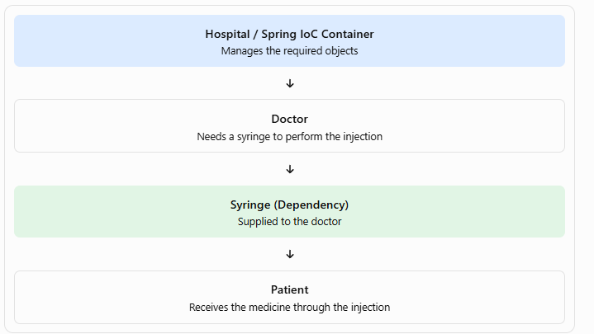

How this relates to Dependency Injection
- Doctor: The class that needs a dependency.
- Syringe: The dependency required by the doctor.
- Hospital / Spring IoC Container: The provider that manages and supplies the required object.
- Injection: The process of supplying the dependency to the doctor.
- Patient: The person receiving the treatment.
In simple words: Just as a doctor can be supplied with a syringe instead of making one, a Spring class receives the objects it needs instead of creating those objects itself. This is called Dependency Injection (DI).
Note: This is an analogy to understand DI. In an actual Spring application, the container injects Java objects into other objects; it does not physically inject anything into a patient.

With Dependency Injection Using a Constructor
A constructor is a special method that runs when an object is created. It is commonly used to provide the required dependencies.
public class StudentService {

private StudentRepository repo;

public StudentService(StudentRepository repo) {
this.repo = repo;
}
}
Here, StudentService does not create the repository object. It receives the object through its constructor.
Spring can provide the repository Bean when it creates StudentService.
For example, if both classes are registered as Spring Beans:
@Repository
public class StudentRepository {
}
@Service
public class StudentService {

private final StudentRepository repo;

public StudentService(StudentRepository repo) {
this.repo = repo;
}
}
Spring creates and manages these objects and injects the repository into the service, provided component scanning and configuration are set up correctly.

Why Do We Use DI?
- It reduces direct dependency between classes.
- It makes it easier to replace one implementation with another.
- It improves testing.
- It allows Spring to manage object creation and connections.

Types of Dependency Injection
Spring supports different ways to inject dependencies.
Constructor Injection
The dependency is provided through the class constructor.
Example: Passing StudentRepository while creating StudentService.
Recommended for required dependencies.
Setter Injection
The dependency is provided through a setter method after the object is created.
public void setRepo(StudentRepository repo) {
this.repo = repo;
}
Example: Spring creates the service object and then calls setRepo() to provide the repository.
Field Injection
The dependency is injected directly into a class field, commonly using @Autowired.
@Autowired
private StudentRepository repo;
It is simple to demonstrate, but constructor injection is generally preferred for required dependencies.

Example : DI Constructor ,DI Getter Setter,Spring Inheritance

